**Non-Stationary Variance Analysis of EPSCs  
John Dempster 3/6/2021**

Import the .WCP data file containing your EPSC recording into the WinEDR program (using File > Import )

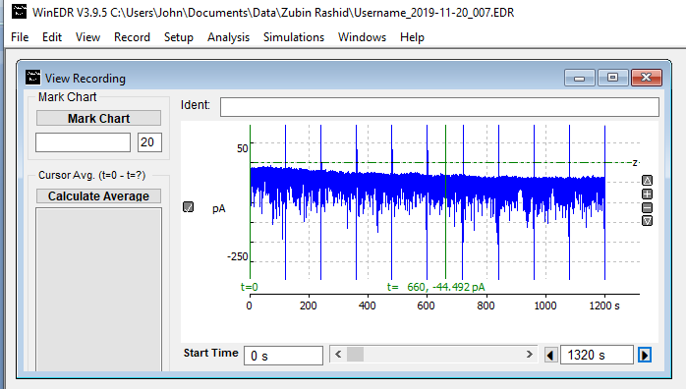

Open the Event Detection module (**Analysis > Detect Events**) and detect the position of the EPSPCs with the data using the settings shown below

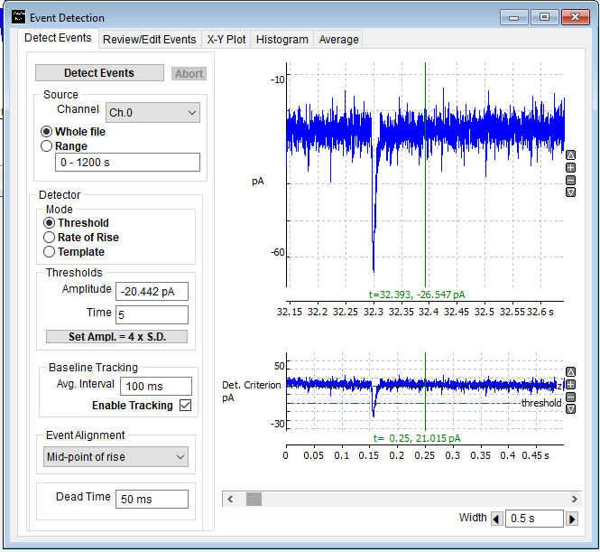

Use the **Event Filter** function to delete superimposed EPSCs, non-EPSCs signals, events with unstable baseline, EPSCs which rise too slowing.

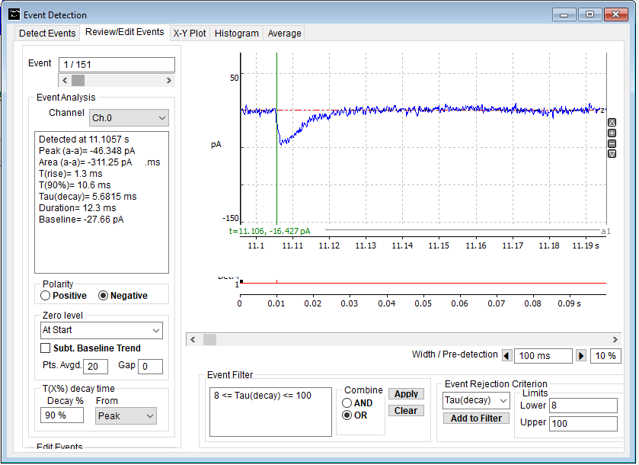

E.g. Remove EPSCs, with peak amplitude >= than -200 pA, rise times > 2 ms. Decay time constant > 8 ms. Then inspect remaining events visually and use the F2 button to delete superimposed EPSCs..

Then select **Export Events** and create a .WCP data file containing the remaining EPSCs.

You can now use WinWCP to apply non-stationary variance analysis to this file. Run WinWCP and open the .WCP file you have created. Then open the Non-stationary variance analysis module.

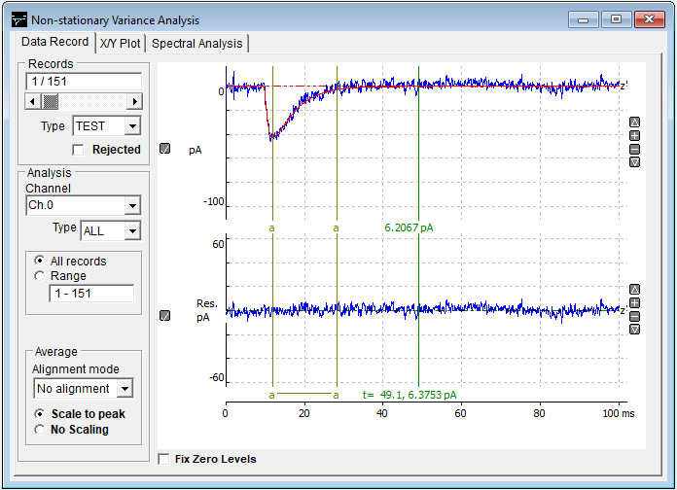

Drag the **a-a** analysis cursors to define a region on the recording starting at the peak of the EPSC and ending at the end of the decay (see above).

Move to the X/Y Plot page, select **X Axis = Mean**, **Y Axis = Variance** and click **New Plot** to plot a variance-mean current for the decaying part of the set of EPSPs in the WCP file.

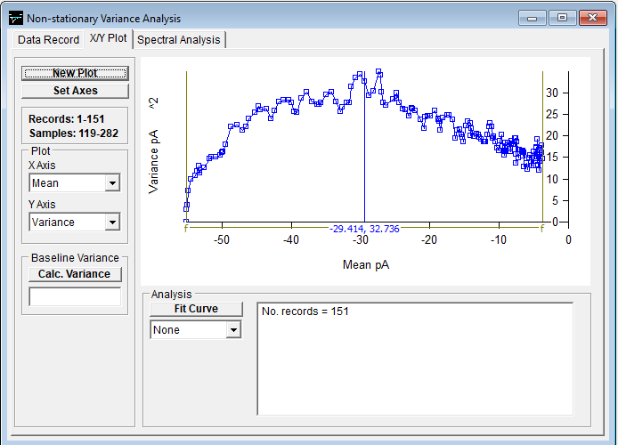

Select **Parabola** as the fitting equation and click **Fit Curve** to fit a parabola to the variance-mean curve,

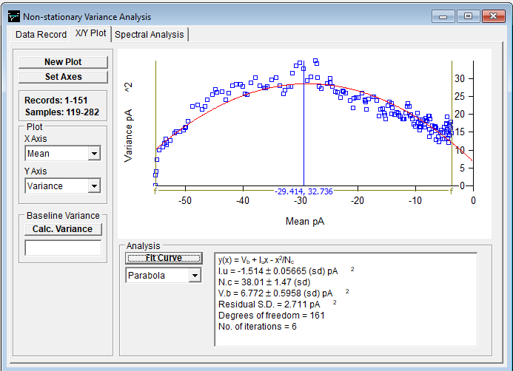

The results compute an estimate of the single-channel current for channels activated by the EPSC Iu = -1.5 pA and the average number of channels activated by an EPSC, Nc=38